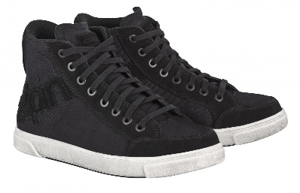

Smelly shoes – oo – u “Ewwww, you have smelly shoes!”

ew and ui are twins (not identical) because they have 2 sounds that are the same (oo and u).

ew is found at the end of a word.
ui is never at the end of a word.

(each code has the same 2 sounds (oo and u)
ew (oo sound) | ew (u sound) | ui (oo sound) | ui (u sound)
grew | new | fruit | nuisance

Why are ew and ui called twins?

What are the two sounds of ui?

When do you use ui?

When do you use ew?

