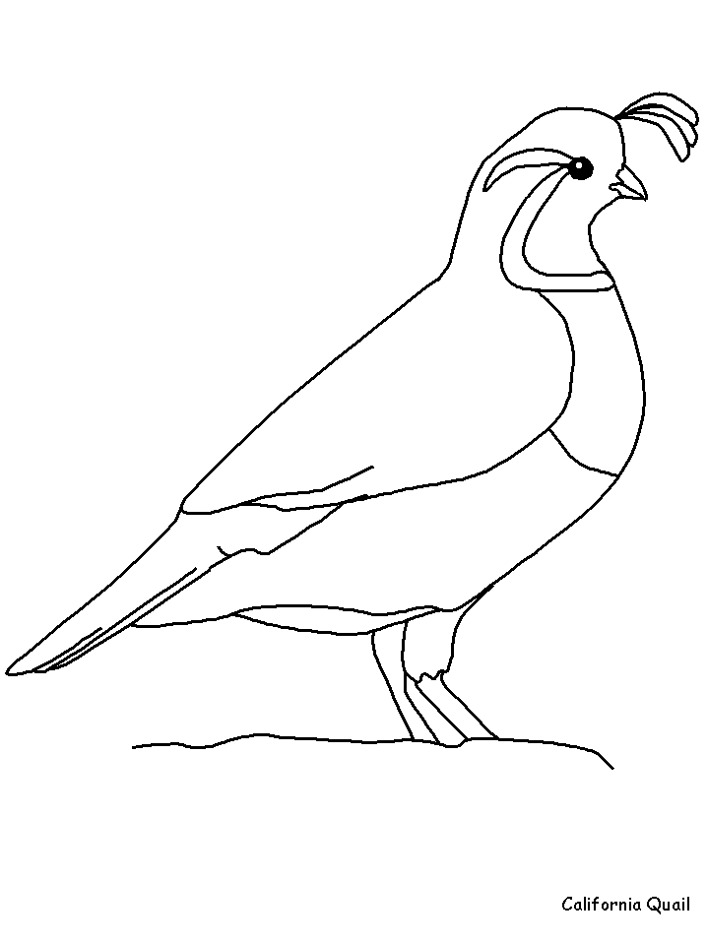**qu words**

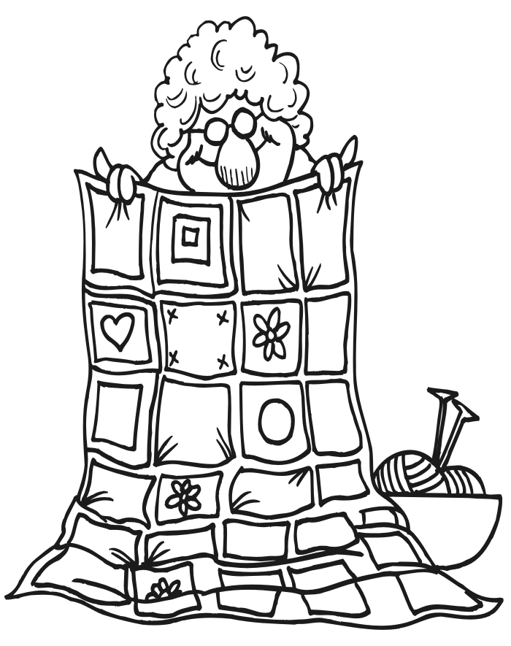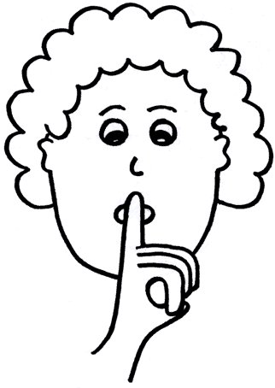

?

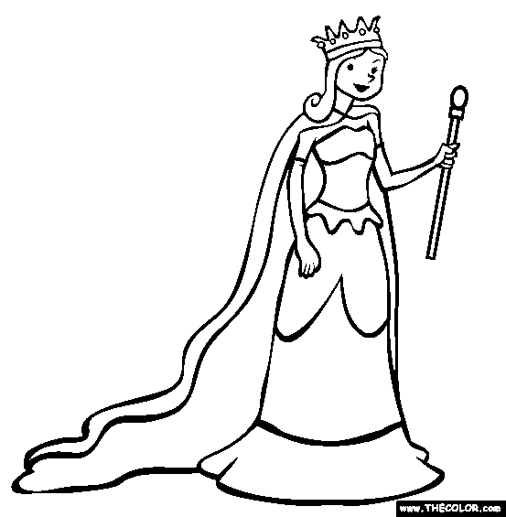

[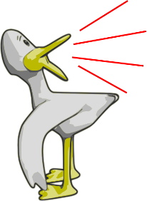](http://www.google.com.au/url?sa=i&rct=j&q=&esrc=s&source=images&cd=&cad=rja&uact=8&ved=0ahUKEwisi8ma2qnMAhVJGpQKHfWiAGAQjRwIBw&url=http%3A%2F%2Fworldartsme.com%2Fquack%2F&bvm=bv.119745492,d.dGo&psig=AFQjCNEkrWQ0MSgNO-W37AqX6qqQtr8fHA&ust=1461670778762030)[](http://www.google.com.au/url?sa=i&rct=j&q=&esrc=s&source=images&cd=&cad=rja&uact=8&ved=&url=http://www.gograph.com/vector-clip-art/squeaking.html&bvm=bv.119745492,d.dGo&psig=AFQjCNGj_ruUVCHYYfPk3Q0k3VDqYB-Tyw&ust=1461670543345690)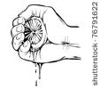







Now pick 5 of these words and write them in a sentence below.

1.

2.

3.

4.

5.