Spicy pumpkin bread

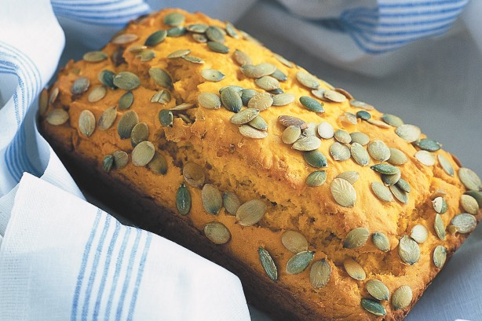
- Ingredients
- Melted butter, to grease
- 300g (2 cups) self-raising flour
- 1/2 teaspoon salt
- 1/2 teaspoon mild chilli powder
- 450g (1 cup) mashed cooked pumpkin
- 125ml (1/2 cup) milk
- 60g butter, melted, cooled
- 2 eggs, lightly whisked
- 2 tablespoons pepitas (pumpkin seed kernels)

- Preheat oven to 180°C. Brush an 11 x 21cm (base measurement) loaf pan with melted butter to lightly grease. Sift the flour, salt and chilli powder into a large bowl. Make a well in the centre.

- Place the pumpkin, milk, butter and egg in a jug, and use a whisk to stir until well combined. Add the pumpkin mixture to the flour mixture, and stir with a large metal spoon until just combined. Spoon the mixture into the prepared pan and smooth the surface. Sprinkle evenly with pepitas.

- Bake in preheated oven for 35-40 minutes or until a skewer inserted into the centre comes out clean. Remove from oven. Set aside in the pan for 5 minutes before turning onto a wire rack to cool

