RULE 9 – 1-1-1
I’m seeing double

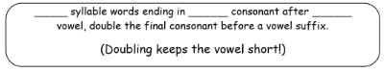

The “1-1-1” rule – words with 1 syllable and 1 vowel followed by 1 consonant must double the last letter before adding an ending that begins with a vowel.
hop + ing = hop ping writ + en = writ ten

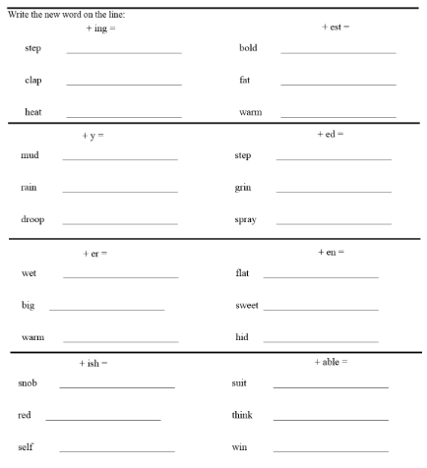

6. forgettable or forgetable?
7. quicker or quickker?
8. planning or planing?
9. budgetting or budgeting?
10. quizzed or quized?

Which of these are right? Use your visual memory for what looks right or the rule.
1. shoper or shopper?
2. foxes or foxxes?
3. beginner or beginer?
4. fatest or fattest?
5. sleeping or sleepping?

