Rule 7 – Secret Agent
Silent Final ‘e’ (SFE)
Silent Final ‘e’ has 5 jobs they are:
Job 1 – In the word ‘time’ SFE is jumping over the m to make i say its second sound.
Job 2 – In the word ‘have’ SFE is stopping the v from being at the end of a word (the same for words ending with u, like blue). (stops v and u from being at the end of a word)
Job 3 – In the word ‘chance’ SFE is making the c say its second sound ‘s’ (the same for words ending with ‘g’, like charge).
Job 4 – In the word ‘lit tle’ SFE is there because every syllable must have a vowel.
Job 5 – In the word ‘are’ SFE is there for no good reason! The SFE is an imposter and doesn’t really have any job to do.
Find 15 words in total – 3 are double agents.
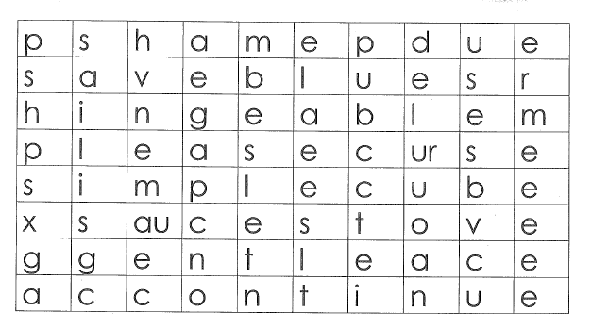
cube | save | continue | sauce
stove | shame | gentle | please
simple | due | curse | able
ace | blue | hinge

Put the following words into the column which shows the job they are doing

Job 1 | Job 2 | Job 3 | Job 4 | Job 5
Double Agents (write double agents here).

