Pumpkin scones
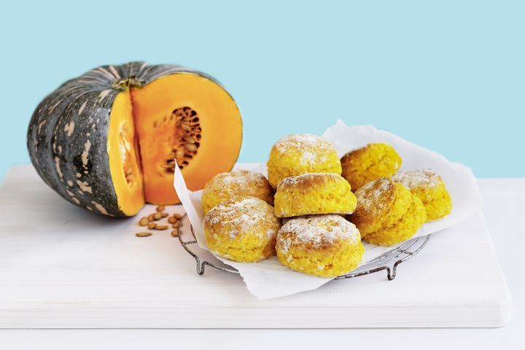

Ingredients
- 600g Kent pumpkin, seeded, peeled, coarsely chopped
- Butter, at room temperature, to grease
- 450g (3 cups) self-raising flour
- Pinch of salt
- 60g chilled butter, cut into 1cm pieces
- 250ml (1 cup) buttermilk
Cook pumpkin in a saucepan of boiling water for 10 minutes or until very tender. Drain. Use a potato masher to mash until a coarse puree forms. Set aside to cool.
Preheat oven to 240°C. Rub a baking tray with butter to grease. Combine the flour and salt in a large bowl. Rub the butter into the flour mixture until the mixture resembles fine breadcrumbs. Add pumpkin and buttermilk. Use a flat-bladed knife in a cutting motion to mix until evenly incorporated and the mixture just starts to hold together.
Turn the dough onto a floured surface and gently knead until smooth. Use your hands to press out the dough until about 2cm thick. Use a round 5.5cm pastry cutter to cut 15 discs from the dough. Place, about 1cm apart, on the prepared tray. Bake for 12 minutes or until golden and scones sound hollow when tapped on the base.

