Pumpkin and Sultana Muffins

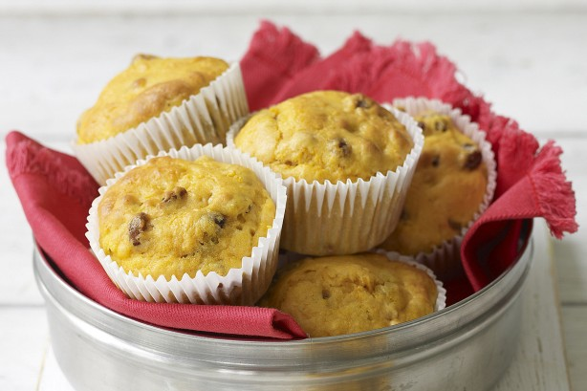

- 1 3/4 cups self-raising flour, sifted
- 1 teaspoon baking powder
- 1/3 cup brown sugar
- 3/4 cup milk
- 2 tablespoon vegetable oil
- 1 cup sultanas
- 1 cup cooked, mashed pumpkin
- 1 egg, lightly beaten

- Preheat oven to 180C or 160C fan-forced. Grease a 12-hole muffin pan .
- Combine flour, baking powder and sugar in a large bowl.
In a separate bowl or jug, whisk together milk, egg and oil. Add to flour with sultanas and pumpkin. Mix together until just combined.
Fill muffin trays. Bake for 20-25 mins until cooked when tested with a skewer. Cool on a wire rack.

