Pumpkin and Chickpea salad
- 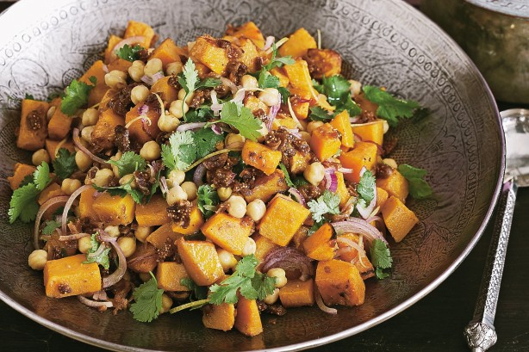

- 1.2kg pumpkin, peeled, deseeded, cut into 2cm pieces
- 1/3 cup olive oil
- 1 teaspoon ground coriander
- 1 teaspoon ground cumin
- 400g can chickpeas
- 3 dried figs finely chopped
            - 1 small red onion, halved, thinly sliced
- 1/2 cup coriander leaves, 1 cup of rocket or spinach finely chopped.
- 1 large lemon, rind grated and juiced

- Preheat oven to 200C. Lightly grease a large roasting pan.
- Combine pumpkin, 2 tablespoons oil, ground coriander and cumin
- in a large bowl. Season with salt and pepper.
- Transfer to prepared pan. Roast for 20 minutes or until pumpkin is
tender. Allow to cool.
Combine pumpkin, chickpeas, figs, onions and chopped coriander in a
- large bowl.
- Combine remaining 2 tablespoons oil, lemon rind, 2 tablespoons juice
- and salt and pepper in a jug. Pour over pumpkin, toss until well
- combined.

