Brown lentil salad

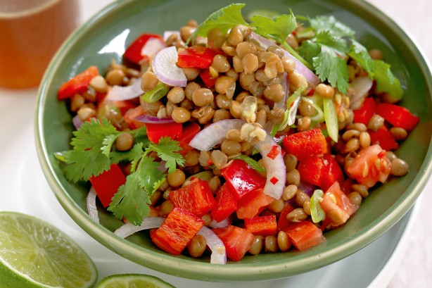

- 400g can lentils, drained, rinsed
- 1/2 small red onion, thinly sliced
- 1 medium tomato, chopped
- 1 green onion, thinly sliced
- 1/2 small red capsicum, chopped
- 1 chilli, deseeded, finely chopped
- 1 tablespoon lime juice
- 2 teaspoons fish sauce
- 1/3 cup fresh coriander leaves
- Step 1
Place lentils, red onion, tomato, green onion, capsicum, chilli, lime juice and fish sauce in a large bowl. Season with pepper. Toss to combine. Sprinkle with coriander. Serve.

